LAB 10
Finite State Machine (FSM)
Using Xilinx ISE Project Navigator and
Nexys2 FPGA Development Board

Acknowledgements: Developed by Ui Luu, Engineering & Electronic Faculty at Glendale College, Glendale, Arizona and Bassam Matar, Engineering Faculty at Chandler-Gilbert Community College, Chandler, Arizona. Funded by NSF
Lab Summary:
We will show
1) A system approach using block diagram & state diagram to create a Finite State Machine (FSM) for a Security Monitor & Alarm system. We will create a top level module (SECURITY.vhd) to link together all components: FSM.vhd(Finite State Machine), TIMER_DISPLAY.vhd (to provide timer & control for 7-segment LED display), MEM16.vhd (Memory Module for displaying 7-segment LEDs), INDICATORS.vhd (to provide visual feedback for NEXYS2 on board switches & buttons) and SECURITY.ucf (I/O assignments for NEXYS2-1200)

(Note: TIMER_DISPLAY.vhd, MEM16.vhd (LED_DRIVER), SECURITY.ucf were covered in Workshop #1, for efficiency, source codes for these modules are provided in the SecurityStateMachine_Starter project folder)

2) use the software application Xilinx Project Navigator ISE to develop the VHDL code for the components that make up the Security State Machine and then program it to the Nexys2 FPGA device.

Lab Goal: The goal of this lab is to implement a Finite State Machine, using a top level module to link together all project components and create components using VHDL.

Learning Objectives
- Create a top-level HDL structure
- Write VHDL code to describe a synchronous state machine diagram
- Apply VHDL codes previously developed in workshop #1 (TIMER_DISPLAY.vhd, MEM16.vhd, SECURITY.ucf module) for timer display
- Develop INDICATORS.vhd (to provide visual feedback for NEXYS2 on board switches & buttons)
- Verify system operations

Grading Criteria: Your grade will be determined by your instructor.

Time Required: 2- 3 hours

Special Safety Requirements

Static electricity can damage the FPGA devices used in this lab. Use appropriate ESD methods to protect the devices. Be sure to wear a grounded wrist-strap at all times while handling the electronic components in this circuit.

No serious hazards are involved in this laboratory experiment, but be careful to connect the components with the proper polarity to avoid damage.

Lab Preparation
- Review result LED_DRIVER from workshop #1:
Appendix 3: TIMER_DISPLAY.vhd (provides timer & control for 7-segment LED display)
Appendix 4: MEM16.vhd (Memory Module for displaying 7-segment LEDs)
Refer to Figure 3 for system block diagram & interface

- Review “Introduction to Xilinx” previous lab.
- Acquire required hardware components/equipment.
- Print out the laboratory experiment procedure that follows.

Equipment and Materials
Each team of students will need the test equipment, tools, and parts specified below. Students should work in teams of two or three.

Test Equipment and Power Supplies | Quantity
The following items from the Xilinx:  - free software ISE WebPACK (www.xilinx.com) that can be installed on your personal computer or full version of Xilinx in your classroom  - Nexys2 FPGA kit including download and power cable  - Free Digitlent Adept software : http://www.digilentinc.com/Products/Detail.cfm?NavPath=2,66,828&Prod=ADEPT2 | 1

Additional References:
1. Xilinx Nexys2 FPGA Reference Manual and Schematic from:
http://www.digilentinc.com/Products/Detail.cfm?Prod=NEXYS2

Resource for Instructors: (Appendix)

- Security State Machine / SECURITY.vhd (Top-Level module that ties the following sub modules together)
    - FSM.vhd (Security State Machine)
    - INDICATORS.vhd (Connect LED Indicators to reflect NEXYS2-1200 onboard switches)

    - TIMER_DISPLAY.vhd (Provide timer & 7-segment LED display timing control)
    - MEM16.vhd (Memory for Cathode control of 7-segment LED display)

    - SECURITY.ucf (I/O Assignments for NEXYS2-1200 demo board)

INTRODUCTION

In this lab, you will create a security system using Finite State Machine (FSM) coding.

A security monitor system consists of the following I/Os:

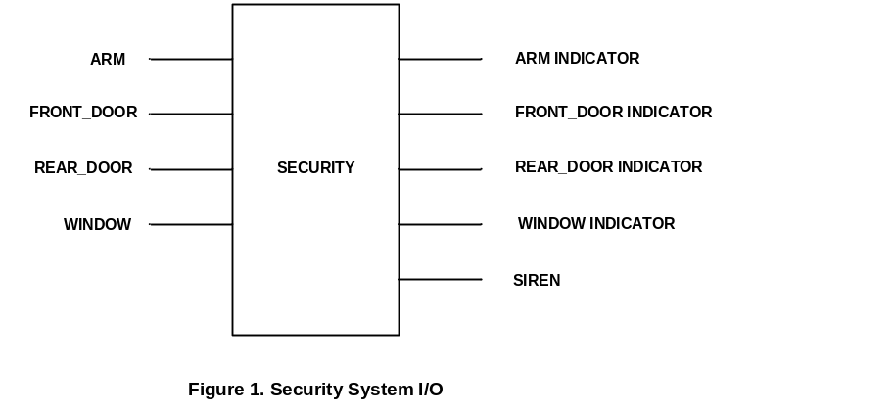

Functional requirement of the security system is described by the following state diagram:

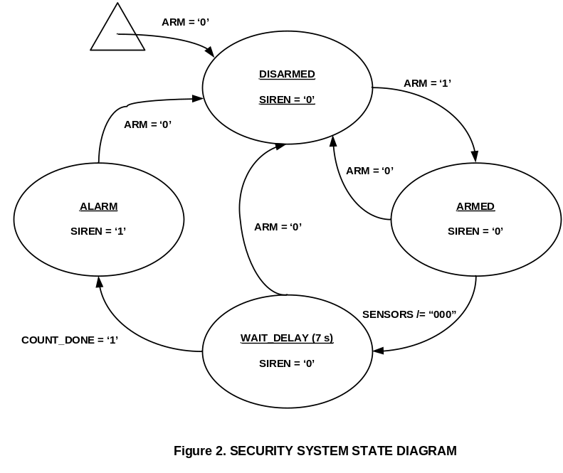

Your task is to write VHDL code to implement the security State Machine.

Upon completion, down load your VHDL code to NEXYS2-1200 demo board and verify the operation of your security system.

Procedure

Consider the following System Block Diagram:
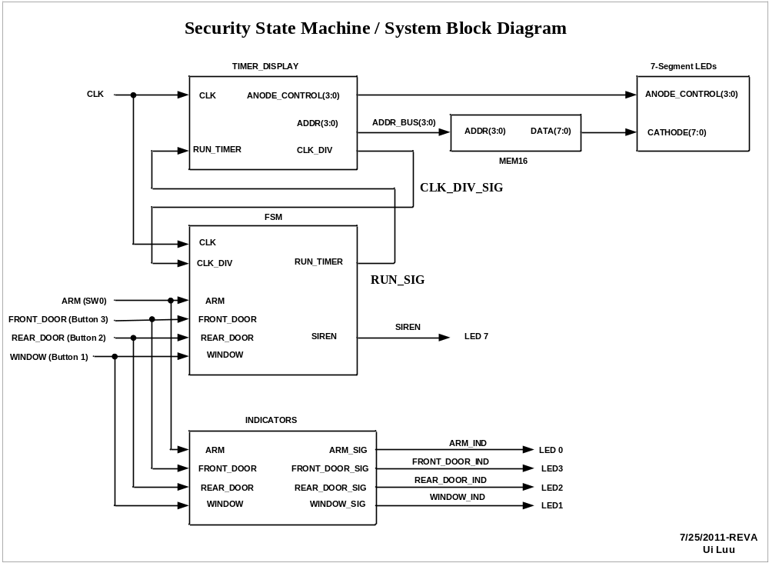

Figure 3. Security State Machine / System Block Diagram

Figure 3 illustrates the Top-Level SECURITY module, it consists of the following sub modules:

- TIMER_DISPLAY provides timing & control signal for Finite State Machine (FSM) and 7-segment LED display
    - Inputs:
      - CLK (system clock running at 5 MHz)
      - RUN_TIMER (from FSM module), this signal controls counter for 7-segment LED display
    - Outputs:
      - CLK_DIV : 1 Hz clock for timer display
      - ADDR(3:0): Address counter to read data from MEM16 module
      - ANODE_CONTROL(3:0): to activate common Anode for 7-segment LED
- MEM16 provides memory for encoding 7-segment LED via table look-ups
    - Inputs:
      - ADDR(3:0): 4-bit address bus for 2⁴ = 16 memory locations
    - Outputs:
      - DATA(7:0): 8-bit data to control CATHODE(7:0) for 7-segment LED display
(Note: NEXYS2 on board 7-segment LED Cathode control is active Low)

- FSM (Finite State Machine) implements Security System State Diagram described in Figure 2
    - Inputs:
      - CLK (system clock running at 5 MHz)
      - CLK_DIV : 1 Hz clock for timer display (This signal is generated by TIMER_DISPLAY module)
      - ARM (SW0)
      - FRONT_DOOR (Button 3)
      - REAR_DOOR (Button 2)
      - Window (Button 1)
    - Outputs:
      - RUN_TIMER: controls 7-segment LED timer display
      - SIREN

- INDICATORS module connects switch & sensor inputs to NEXYS2 on board LED for visual feedback
    - Inputs:
      - ARM
      - FRONT_DOOR
      - REAR_DOOR
      - WINDOW
    - Outputs:
      - ARM _SIG
      - FRONT_DOOR_SIG
      - REAR_DOOR_SIG
      - WINDOW_SIG

In the following steps, we will use System Block Diagram in Fig. 3 as a road map to create the Top-Level Module I/O assignments.

(User’s note: To fit this hands-on activity in a two-hour lab, a “Starter” template is created in “VHDL-SecurityStateMachine-Starter(NEXYS2-1200)” project folder. This template in conjunction with the following instructions will facilitate learning to add source code for the Finite State Machine. )
Step 1: Creating the Top-Level Module (Reference: SECURITY.vhd in Appendix)

  - Open the template project folder: VHDL-SecurityStateMachine-Starter(NEXYS2-1200), double click on Lab.xise

Screen prompt:
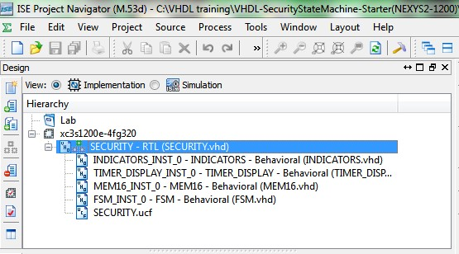
Double click on “SECURITY.vhd” top level module. Screen prompt:

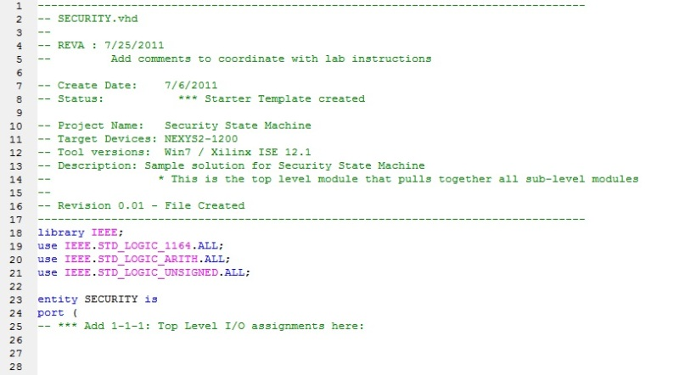

Create a top-level structural module named SECURITY that incorporates the sub modules FSM, TIMER_DISPLAY, MEM16 and INDICATORS as shown in Figure 3. (Note: TIMER_DISPLAY, MEM16 and INDICATORS were covered in previous LED Driver lab, for time efficiency, those components assignments are given in the template)

    - At “SECURITY.vhd”, add the following codes to specify top level I/O port assignments:
entity SECURITY is
port (
CLK : in std_logic;
ARM : in std_logic;
FRONT_DOOR: in std_logic;
REAR_DOOR: in std_logic;
WINDOW: in std_logic;
SIREN : out std_logic;

ARM_IND : out std_logic;
FRONT_DOOR_IND: out std_logic;
REAR_DOOR_IND: out std_logic;
WINDOW_IND: out std_logic;

CATHODE : out STD_LOGIC_VECTOR (7 downto 0);
ANODE_CONTROL :out STD_LOGIC_VECTOR (3 downto 0)
);
end entity SECURITY;

    - Add FSM Component I/O Port assignments: (Reference: Figure 3 / System Block Diagram)

component FSM
Port (
CLK : in STD_LOGIC;
CLK_DIV:in STD_LOGIC;
ARM : in STD_LOGIC;
FRONT_DOOR : in STD_LOGIC;
REAR_DOOR : in STD_LOGIC;
WINDOW : in STD_LOGIC;
RUN_TIMER:out STD_LOGIC;
SIREN : out STD_LOGIC
);
end component;

    - Add port connections for Instance of FSM component: (Reference: Figure 3 / System Block Diagram)

FSM_INST_0: FSM port map (
CLK => CLK,
CLK_DIV => CLK_DIV_SIG,
ARM => ARM,
FRONT_DOOR => FRONT_DOOR,
REAR_DOOR => REAR_DOOR,
WINDOW => WINDOW,
RUN_TIMER => RUN_SIG,
SIREN => SIREN);

(Note: CLK_DIV_SIG & RUN_SIG are signal names created to interconnect between TIMER_DELAY module and FSM Module)

- Review Finite State Machine design before starting Step 2. (Refer to Figure 3: System Block Diagram for I/O Assignments)

Step 2: Creating Finite State Machine (FSM) Module (reference: FSM.vhd in Appendix)

2-1. At the Design window:

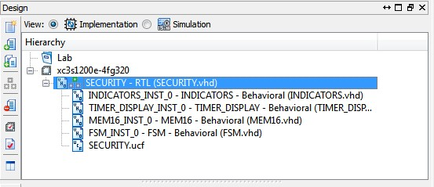
Double click on FSM.vhd to open the module for editing.

The HDL editor opens as shown:
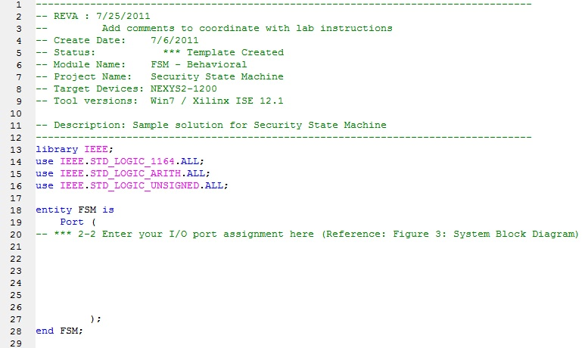

2-2. Enter the following I/O port assignments for entity FSM, using Figure 3: System Block Diagram as reference

entity FSM is
Port ( CLK : in STD_LOGIC;
CLK_DIV:in STD_LOGIC;
ARM : in STD_LOGIC;
FRONT_DOOR : in STD_LOGIC;
REAR_DOOR : in STD_LOGIC;
WINDOW : in STD_LOGIC;
RUN_TIMER:out STD_LOGIC;
SIREN : out STD_LOGIC);
end FSM;

2-3. Between the keyword architecture and begin statements, enter the following codes to declare type & signal names”

type SECURITY_STATE is (ARMED,DISARMED,WAIT_DELAY, ALARM);
signal CURR_STATE,NEXT_STATE: SECURITY_STATE;
signal START_COUNT,COUNT_DONE: std_logic;
signal SENSORS:std_logic_vector (2 downto 0); --combine inputs
signal TIMER_CNTR: std_logic_vector (2 downto 0) := (others => '0');

2-4. Review the following code given in the template:

SENSORS <= FRONT_DOOR & REAR_DOOR & WINDOW;

SYNC: process (CLK,ARM)
begin
if ARM = '0' then
CURR_STATE <= DISARMED;
elsif rising_edge (CLK) then
CURR_STATE <= NEXT_STATE;
end if;
end process SYNC;

2-5. Add the following VHDL codes for your State Machine using Figure 2: Security System State Diagram as reference

STATE_MACHINE: process (CURR_STATE,SENSORS,ARM,COUNT_DONE)
begin

START_COUNT <= '0'; -- establish default

case (CURR_STATE) is
when DISARMED =>
if ARM = '1' then
NEXT_STATE <= ARMED;
else NEXT_STATE <= DISARMED;
end if;
-- Output:
SIREN <= '0';
RUN_TIMER <= '0';
when ARMED =>
if (SENSORS /= "000") then
NEXT_STATE <= WAIT_DELAY;
else NEXT_STATE <= ARMED;
end if;
-- Output:
SIREN <= '0';
RUN_TIMER <= '0';
when WAIT_DELAY =>
START_COUNT <= '1';
if (COUNT_DONE = '1') then
NEXT_STATE <= ALARM;
elsif (ARM ='0') then
NEXT_STATE <= DISARMED;
else NEXT_STATE <= WAIT_DELAY;
end if;
-- Output:
SIREN <= '0';
RUN_TIMER <= '1';
when ALARM =>
if (ARM = '0') then
NEXT_STATE <= DISARMED;
else NEXT_STATE <= ALARM;
end if;
-- Output:
SIREN <= '1';
RUN_TIMER <= '0';
end case;
end process STATE_MACHINE;

2-6. Review Process DELAY_TIMER: (this code is given at the template)

DELAY_TIMER: process(CLK_DIV,CURR_STATE,START_COUNT,TIMER_CNTR)
begin
COUNT_DONE <= '0'; -- default value
if (rising_edge (CLK_DIV) and (START_COUNT = '1')) then
TIMER_CNTR <= TIMER_CNTR + 1;
end if;
-- *** Note: START_COUNT is set to 1 by the STATE_MACHINE in section 2-5 when CURR_STATE = WAIT_DELAY

if (CURR_STATE/=WAIT_DELAY) then -- /= means NOT equal to
TIMER_CNTR <= "000";
end if;

if (TIMER_CNTR = "111") then -- Note: this timer times out at 7 seconds just for convenience
COUNT_DONE <= '1';
end if;

end process DELAY_TIMER;

2-7. Perform a syntax check.

2-7-1. In the Sources window, select FSM module. In the Processes window, double-click Check Syntax.

2-7-2. Correct any errors.

Step 3: Implementing and Downloading the Design

3-1. Select the top-level module SECURITY and implement the design. Then download to the demo board for in-circuit verification.

3-1-1. In the Source window, select the top-level module SECURITY. In the process window, double-click Generate Programming File (Figure 3-1-1)

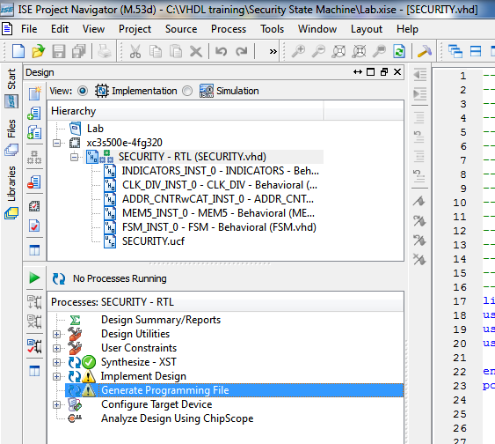

Figure 3-1-1. Generate Programming File

    - A successful operation will provide a green check mark next to Generate Programming File, as shown in the following Figure

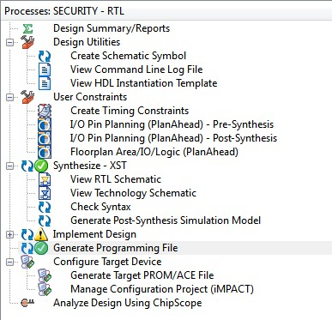

Figure 3-1-2. Successful “Generate Programming File”

Resolve any issues that might prevent a successful creation of the bitstream file. Ask for help from the instructor if needed.

    - Connect the NEXYS2-1200 demo board to the workstation by using the USB connection. Turn on the power to the board.

    - Run Adept (a programming utility from Digilent)

The following screen will appear:

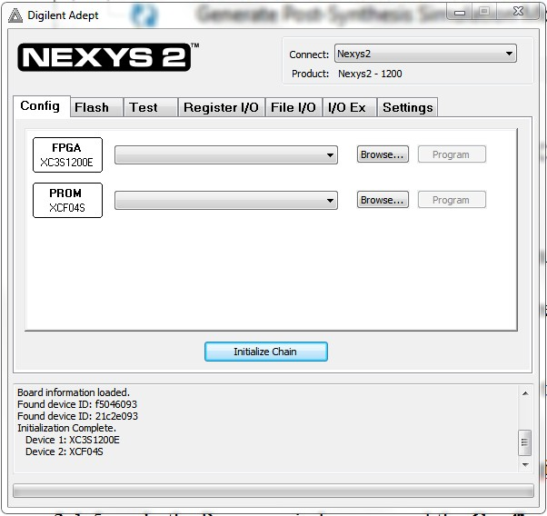

- Verify that the upper right corner
    - Connect: Nexys2
    - Product: Nexys2 – 1200
- Select FPGA / Browse to your working project folder / Security.bit / then Click Open

- The following screen will appear

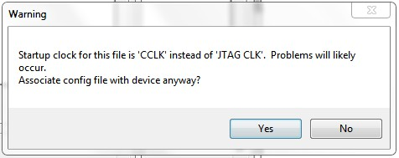

Click “Yes”

Screen prompt:
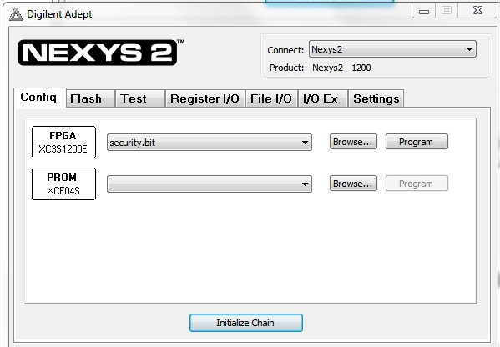

Press “Program” to start down load bitstream to NEXYS2 board

Screen prompt:
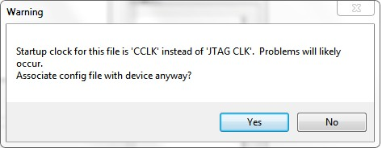

Click “Yes” to continue

After a successful download and device configuration, the following dialog box will appear:

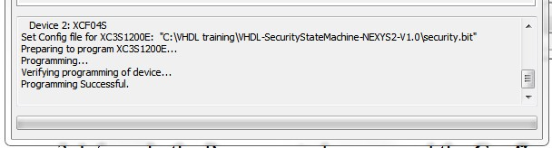

Congratulations! You have completed the Design of Security system, Coding in VHDL, Implement design in FPGA, and successfully downloaded to NEXYS2 demo board.

The Security State Machine is ready for system verification test.

Step 4: System Verification

Use the Security System I/O (Figure 1) and Security System State Diagram (Figure 2) as your guide.
Verify the security system operated as prescribed with all input combinations.
Tabulate your test results with each input combination. Use data to show if the system meets prescribed functional requirements.

Document any system problems, discuss with your team and provide associated solutions.

Sample Source Codes:

Appendix 1: Security.vhd (top level module)
Appendix 2: FSM.vhd (Finite State Machine)
Appendix 3: TIMER_DISPLAY.vhd (provides timer & control for 7-segment LED display)
Appendix 4: MEM16.vhd (Memory Module for displaying 7-segment LEDs)
Appendix 5: INDICATORS.vhd (provides visual feedback for NEXYS2 on board switches & buttons)
Appendix 6: SECURITY.ucf (I/O assignments for NEXYS2-1200)
Appendix 1: Security.vhd (top level module)

----------------------------------------------------------------------------------
-- SECURITY.vhd
--
-- Create Date: 7/6/2011
-- Status: *** Operation verified with NEXYS2-1200.

-- Project Name: Security State Machine
-- Target Devices: NEXYS2-1200
-- Tool versions: Win7 / Xilinx ISE 12.1
-- Description: Sample solution for Security State Machine
-- * This is the top level module that pulls together all sub-level modules
--
-- Revision 0.01 - File Created
----------------------------------------------------------------------------------
library IEEE;
use IEEE.STD_LOGIC_1164.ALL;
use IEEE.STD_LOGIC_ARITH.ALL;
use IEEE.STD_LOGIC_UNSIGNED.ALL;

entity SECURITY is
port (
CLK : in std_logic;
ARM : in std_logic;
FRONT_DOOR: in std_logic;
REAR_DOOR: in std_logic;
WINDOW: in std_logic;
SIREN : out std_logic;

ARM_IND : out std_logic;
FRONT_DOOR_IND: out std_logic;
REAR_DOOR_IND: out std_logic;
WINDOW_IND: out std_logic;

CATHODE : out STD_LOGIC_VECTOR (7 downto 0);
ANODE_CONTROL :out STD_LOGIC_VECTOR (3 downto 0)
);
end entity SECURITY;

architecture RTL of SECURITY is

component FSM
Port ( CLK : in STD_LOGIC;
CLK_DIV:in STD_LOGIC;
ARM : in STD_LOGIC;
FRONT_DOOR : in STD_LOGIC;
REAR_DOOR : in STD_LOGIC;
WINDOW : in STD_LOGIC;
RUN_TIMER:out STD_LOGIC;
SIREN : out STD_LOGIC);
end component;

component TIMER_DISPLAY
Port (CLK: in STD_LOGIC;
CLK_DIV: out STD_LOGIC;
RUN_TIMER: in STD_LOGIC; -- *** RUN_TIMER is output from FSM module
ADDR: out STD_LOGIC_VECTOR(3 downto 0); -- to MEM16 for 7-segment LED Driver using table look-up
ANODE_CONTROL: out STD_LOGIC_VECTOR(3 downto 0) -- for 7-segment LEDs
);
end component;

component MEM16
Port (ADDR: in std_logic_vector (3 downto 0);
DATA: out STD_LOGIC_VECTOR(7 downto 0)); -- DATA to control Cathodes of 7-segment LEDs
end component;

component INDICATORS
Port ( ARM : in STD_LOGIC;
FRONT_DOOR : in STD_LOGIC;
REAR_DOOR : in STD_LOGIC;
WINDOW : in STD_LOGIC;

ARM_SIG : out STD_LOGIC;
FRONT_DOOR_SIG : out STD_LOGIC;
REAR_DOOR_SIG : out STD_LOGIC;
WINDOW_SIG : out STD_LOGIC);
end component;

--signal CE_SIG: std_logic;

signal CLK_DIV_SIG: std_logic;
signal ADDR_BUS: std_logic_vector(3 downto 0);

signal RUN_SIG: std_logic;

begin

INDICATORS_INST_0: INDICATORS port map (
ARM => ARM,
FRONT_DOOR => FRONT_DOOR,
REAR_DOOR => REAR_DOOR ,
WINDOW => WINDOW,

ARM_SIG => ARM_IND,
FRONT_DOOR_SIG => FRONT_DOOR_IND,
REAR_DOOR_SIG => REAR_DOOR_IND,
WINDOW_SIG => WINDOW_IND
);

TIMER_DISPLAY_INST_0: TIMER_DISPLAY port map (
CLK=>CLK,
CLK_DIV => CLK_DIV_SIG,
RUN_TIMER => RUN_SIG,
ADDR => ADDR_BUS,
ANODE_CONTROL=>ANODE_CONTROL
);

MEM16_INST_0: MEM16 port map (ADDR=> ADDR_BUS, DATA=>CATHODE);

FSM_INST_0: FSM port map (
CLK => CLK,
CLK_DIV => CLK_DIV_SIG,
ARM => ARM,
FRONT_DOOR => FRONT_DOOR,
REAR_DOOR => REAR_DOOR,
WINDOW => WINDOW,
RUN_TIMER => RUN_SIG,
SIREN => SIREN);

end architecture RTL;

Appendix 2: FSM.vhd (Finite State Machine)

----------------------------------------------------------------------------------
-- Create Date: 7/6/2011
-- Status: *** Operation verified with NEXYS2-1200
-- Module Name: FSM - Behavioral
-- Project Name: Security State Machine
-- Target Devices: NEXYS2-1200
-- Tool versions: Win7 / Xilinx ISE 12.1
-- Description: Sample solution for Security State Machine
----------------------------------------------------------------------------------
library IEEE;
use IEEE.STD_LOGIC_1164.ALL;
use IEEE.STD_LOGIC_ARITH.ALL;
use IEEE.STD_LOGIC_UNSIGNED.ALL;

entity FSM is
Port ( CLK : in STD_LOGIC;
CLK_DIV:in STD_LOGIC;
ARM : in STD_LOGIC;
FRONT_DOOR : in STD_LOGIC;
REAR_DOOR : in STD_LOGIC;
WINDOW : in STD_LOGIC;
RUN_TIMER:out STD_LOGIC;
SIREN : out STD_LOGIC);
end FSM;

architecture Behavioral of FSM is
type SECURITY_STATE is (ARMED,DISARMED,WAIT_DELAY, ALARM);
signal CURR_STATE,NEXT_STATE: SECURITY_STATE;
signal START_COUNT,COUNT_DONE: std_logic;
signal SENSORS:std_logic_vector (2 downto 0); --combine inputs
signal TIMER_CNTR: std_logic_vector (2 downto 0) := (others => '0');

begin
SENSORS <= FRONT_DOOR & REAR_DOOR & WINDOW;

SYNC: process (CLK,ARM)
begin
if ARM = '0' then
CURR_STATE <= DISARMED;
elsif rising_edge (CLK) then
CURR_STATE <= NEXT_STATE;
end if;
end process SYNC;

STATE_MACHINE: process (CURR_STATE,SENSORS,ARM,COUNT_DONE)
begin

START_COUNT <= '0'; -- establish default

case (CURR_STATE) is
when DISARMED =>
if ARM = '1' then
NEXT_STATE <= ARMED;
else NEXT_STATE <= DISARMED;
end if;
-- Output:
SIREN <= '0';
RUN_TIMER <= '0';
when ARMED =>
if (SENSORS /= "000") then
NEXT_STATE <= WAIT_DELAY;
else NEXT_STATE <= ARMED;
end if;
-- Output:
SIREN <= '0';
RUN_TIMER <= '0';
when WAIT_DELAY =>
START_COUNT <= '1';
if (COUNT_DONE = '1') then
NEXT_STATE <= ALARM;
elsif (ARM ='0') then
NEXT_STATE <= DISARMED;
else NEXT_STATE <= WAIT_DELAY;
end if;
-- Output:
SIREN <= '0';
RUN_TIMER <= '1';
when ALARM =>
if (ARM = '0') then
NEXT_STATE <= DISARMED;
else NEXT_STATE <= ALARM;
end if;
-- Output:
SIREN <= '1';
RUN_TIMER <= '0';
end case;
end process STATE_MACHINE;

DELAY_TIMER: process(CLK_DIV,CURR_STATE,START_COUNT,TIMER_CNTR)
begin
COUNT_DONE <= '0'; -- default value
if (rising_edge (CLK_DIV) and (START_COUNT = '1')) then
TIMER_CNTR <= TIMER_CNTR + 1;
end if;

if (CURR_STATE/=WAIT_DELAY) then
TIMER_CNTR <= "000";
end if;

if (TIMER_CNTR = "111") then
COUNT_DONE <= '1';
end if;

end process DELAY_TIMER;

end Behavioral;
Appendix 3: TIMER_DISPLAY.vhd

----------------------------------------------------------------------------------
-- TIMER_DISPLAY.vhd
--
-- Create Date: 7/6/2011
-- Status: *** Operation verified with NEXYS2-1200

-- Target Devices: NEXYS2-1200
-- Tool versions: Win7 / Xilinx ISE 12.1

-- Description: This module provide timer & control for 7-segment LED display

-- Revision 0.01 - File Created
----------------------------------------------------------------------------------
library IEEE;
use IEEE.STD_LOGIC_1164.ALL;
use IEEE.STD_LOGIC_ARITH.ALL;
use IEEE.STD_LOGIC_UNSIGNED.ALL;
use IEEE.NUMERIC_STD.ALL;

entity TIMER_DISPLAY is
Port ( CLK : in STD_LOGIC;
CLK_DIV : out STD_LOGIC;
RUN_TIMER: in STD_LOGIC; -- *** RUN_TIMER is output from FSM module
ADDR: out STD_LOGIC_VECTOR(3 downto 0);
ANODE_CONTROL: out STD_LOGIC_VECTOR(3 downto 0)
);
end TIMER_DISPLAY;

architecture Behavioral of TIMER_DISPLAY is

signal REG : std_logic_vector(27 downto 0) := (others => '0');
signal CLK_DIV_INT :STD_LOGIC;
signal Q_INT: std_logic_vector(3 downto 0);

begin

process (CLK,REG) begin
if rising_edge(CLK) then
REG <= REG + 1; CLK_DIV_INT<='0';
end if;

if REG = X"2FAF080" then -- For 1 Hz use X"2FAF080" = 50,000,000 (Decimal)
-- 50 MHz / 50,000,000 = 1 Hz
CLK_DIV_INT<='1';
REG<=X"0000000";

end if;

end process;

process (CLK,CLK_DIV_INT,RUN_TIMER)
begin
if RUN_TIMER = '0' then
Q_INT <= (others => '0');
elsif rising_edge(CLK) then
if (CLK_DIV_INT='1') then
Q_INT <= Q_INT + '1';
end if;
end if;

end process;

-- Outputs:
ADDR(3 downto 0) <= Q_INT (3 downto 0);
ANODE_CONTROL <= "1110"; -- Enable 1st digit only, active Low
CLK_DIV <=CLK_DIV_INT;
end Behavioral;
Appendix 4: MEM16.vhd (Memory Module for displaying 7-segment LEDs)

----------------------------------------------------------------------------------
-- MEM16.vhd
--
-- Create Date: 7/6/2011
-- Status: *** Operation verified with NEXYS2-1200

-- Target Devices: NEXYS2-1200

-- Tool versions: Win7 / Xilinx ISE 12.1

-- Description: Sample Solution for Memory Module for displaying 7-segment LEDs
--
-- Revision 0.01 - File Created
----------------------------------------------------------------------------------
library IEEE;
use IEEE.STD_LOGIC_1164.ALL;
use IEEE.STD_LOGIC_ARITH.ALL;
use IEEE.STD_LOGIC_UNSIGNED.ALL;

entity MEM16 is
Port ( ADDR : in STD_LOGIC_VECTOR (3 downto 0);
DATA : out STD_LOGIC_VECTOR (7 downto 0));
end MEM16;

architecture Behavioral of MEM16 is
type ROM_ARRAY is array (0 to 15) of std_logic_vector(7 downto 0);
constant MY_ROM :ROM_ARRAY :=(
-- Cathode Control for 7-SEGMENT LED Digit (0-F):
0 => X"03", --0 note: Cathode control is active Low
1 => X"9F", --1
2 => X"25", --2
3 => X"0D", --3
4 => X"99", --4
5 => X"49", --5
6 => X"41", --6
7 => X"1F", --7
8 => X"01", --8
9 => X"09", --9
10 => X"11", --A
11 => X"C1", --B
12 => X"63", --C
13 => X"85", --D
14 => X"61", --E
15 => X"71" --F
);
begin
DATA <= MY_ROM(conv_integer(ADDR));
end Behavioral;

Appendix 5: INDICATORS.vhd (provides visual feedback for NEXYS2 on board switches & buttons)

----------------------------------------------------------------------------------
-- INDICATORS.vhd
--
-- Create Date: 5/10/2011
-- Status: *** Operation verified with NEXYS2

-- Project Name: Security State Machine
-- Target Devices: NEXYS2-1200
-- Tool versions: Win7 / Xilinx ISE 12.1

-- Description: This Module provide visual feedback for NEXYS2 on board switches & buttons
-- Revision 0.01 - File Created
----------------------------------------------------------------------------------
library IEEE;
use IEEE.STD_LOGIC_1164.ALL;
use IEEE.STD_LOGIC_ARITH.ALL;
use IEEE.STD_LOGIC_UNSIGNED.ALL;

entity INDICATORS is
Port ( ARM : in STD_LOGIC;
FRONT_DOOR : in STD_LOGIC;
REAR_DOOR : in STD_LOGIC;
WINDOW : in STD_LOGIC;

ARM_SIG : out STD_LOGIC;
FRONT_DOOR_SIG : out STD_LOGIC;
REAR_DOOR_SIG : out STD_LOGIC;
WINDOW_SIG : out STD_LOGIC);
end INDICATORS;

architecture Behavioral of INDICATORS is

begin

ARM_SIG<=ARM;
FRONT_DOOR_SIG <= FRONT_DOOR;
REAR_DOOR_SIG <= REAR_DOOR;
WINDOW_SIG <= WINDOW;

end Behavioral;

Appendix 6: SECURITY.ucf (I/O assignments for NEXYS2-1200)

# SECURITY.ucf
# 7/6/2011: Operation verified with NEXYS2-1200

NET "CLK" LOC = B8;
NET "ARM" LOC = G18; # Switch 0

NET "FRONT_DOOR" LOC = H13; # Button 3
NET "REAR_DOOR" LOC = E18; # Button 2
NET "WINDOW" LOC = D18; # Button 1

NET "ARM_IND" LOC = J14; #LED 0

NET "FRONT_DOOR_IND" LOC = K14; #LED3
NET "REAR_DOOR_IND" LOC = K15; #LED2
NET "WINDOW_IND" LOC = J15; #LED1

NET "CATHODE[0]" LOC = C17; #DP
NET "CATHODE[1]" LOC = H14; #CG
NET "CATHODE[2]" LOC = J17; #CF
NET "CATHODE[3]" LOC = G14; #CE
NET "CATHODE[4]" LOC = D16; #CD
NET "CATHODE[5]" LOC = D17; #CC
NET "CATHODE[6]" LOC = F18; #CB
NET "CATHODE[7]" LOC = L18; #CA

NET "ANODE_CONTROL[0]" LOC = F17;
NET "ANODE_CONTROL[1]" LOC = H17;
NET "ANODE_CONTROL[2]" LOC = C18;
NET "ANODE_CONTROL[3]" LOC = F15;

NET "SIREN" LOC = P4; #LED7 P4 for NE

